
Editor: Associate Professor Wendy Fox-Turnbull, University of Waikato, New Zealand

Editorial board:
Prof Stephanie Atkinson, Sunderland University, England, United Kingdom Prof Marc de Vries, Delft University of Technology, Netherlands
Prof Mishack Gumbo, University of South Africa, South Africa Prof Jonas Hallström, Linkoping University, Sweden
Assoc Prof Kurt Seemann, Swinburne University of Technology Australia, Australia Prof David Spendlove, University of Manchester, England, United Kingdom
Prof Scott Warner, Millersville University, United States
Assoc Prof P John Williams, Curtin University, Western Australia, Australia

The Australasian Journal of Technology Education is a peer refereed journal and provides a forum for scholarly discussion on topics relating to technology education. Submissions are welcomed relating to the primary, secondary and higher education sectors, initial teacher education and continuous professional development, and general research about technology education. Contributions to the ongoing research debate are encouraged from any country. The expectation is that the Journal will publish articles at the leading edge of development of the subject area.

The Journal seeks to publish
- reports of research,
- articles based on action research by practitioners,
- literature reviews, and
- book reviews.
Publisher: The Technology, Environmental, Mathematics and Science (TEMS) Education Research Centre, which is part of the Division of Education, The University of Waikato, publishes the journal.
Contact details: The Editor, AJTE, wendy.fox-turnbull@waikato.ac.nz
Cover Design: Roger Joyce
This journal provides immediate open access to its content on the principle that making research freely available to the public supports a greater global exchange of knowledge.

ISSN: 2382-2007

Agency in the Making: Empowering Pre-Service Technology Teachers

Rob Rouse | David Ellis | Carol K. Puddicombe
School of Education | Faculty of Education | School of Education
The University of Queensland | Southern Cross University | Edith Cowan University
Australia  Abstract | Australia | Australia
Technology teachers routinely make informed decisions about the materials and processes their students use to create artefacts. Thus, it is important to expose pre-service technology teachers to learning environments in which they develop agency towards making. We take the stance that developing pre-service technology teachers’ agency towards making will prepare them to become bold and confident makers in their own classrooms when they become teachers, resulting in them launching innovative maker projects and supporting their own students throughout the process. In this paper, we present three case studies—drawn from initial teacher education programs at three different Australian universities—in which pre-service technology teachers increased their agency towards making. In the first case study, we describe how pre-service primary teachers participated in a variety of activities in a university makerspace. In the second case study, we explain how pre-service secondary teachers solved unique open-ended challenges by blending the design process with using digital fabrication tools. In the third case study, we outline how pre-service teachers engaged in solving a values-based task to prepare them for engaging with values such as sustainability and global citizenship in the Australian curriculum. Recommendations and next steps are discussed.

Keywords
Agency, pre-service teachers, technology, making, makerspaces

Introduction
Technology education, which has evolved significantly from its roots in industrial and manual arts, now emphasises design-focused thinking, innovation, and the development of artefacts and prototypes (Puddicombe & Williams, 2020). Across Australia, universities offering programs in initial teacher education (ITE) face increasing pressure to attract, prepare, and retain qualified educators capable of leading technologically literate classrooms (Williams, 2023). In this paper, we present three case studies exploring how different Australian universities conceptualise and deliver their technology ITE

programs. These case studies contribute to ongoing national and international discussions concerning the sustainability, visibility, and future direction of technology teacher education.

Empowering Pre-Service Technology Teachers
Global initiatives focused on improving the quality of the teaching profession have resulted in the establishment of rigorous teaching standards across different nations (OECD, 2011). These standards—useful for initial teacher education programs, accrediting authorities, pre-service teachers, and experienced educators—explicitly state what teachers need to know and what they should be able to do (Darling-Hammond, 2021). In Australia, the Australian Professional Standards for Teachers outline the professional knowledge and practices graduates of initial teacher education programs must be able to demonstrate (AITSL, 2011). While it is critically important to assess pre-service teachers’ knowledge and skills in relation to established professional standards, we argue that it is equally important to prepare teachers to exercise agency—the confidence and ability to contribute to shaping classroom, school, and workplace conditions (Biesta et al., 2015; Emans et al., 2025).
In addition to demonstrating the knowledge and practices outlined in the Australian Professional Standards for Teachers, technology teachers in Australia are also responsible for teaching the knowledge, processes, and skills listed in the Australian Curriculum (ACARA, 2022). This requires technology teachers to possess not only factual and conceptual knowledge, but knowledge involving the practical work of manipulating objects and materials (Millar, 2004). Because of the nature of the technology curriculum and its emphasis on design thinking and artefact creation, technology teachers are particularly well-positioned to exercise agency towards making—an activity that has become increasingly prevalent in schools—especially those with makerspaces (Rouse & Gillespie Rouse, 2022; Davies & Seitamaa-Hakkarainen, 2025). By this, we mean that technology teachers routinely make informed decisions about the materials (e.g., software, hardware) and processes their students use to make artefacts.

Harnessing the Power of Making
University makerspaces are sites where students have access to an array of physical and digital technologies that promote designing, making, and innovation (Farritor, 2017; Pettersen et al., 2020). Although university makerspaces have long been a valued component of undergraduate engineering education (Barrett et al., 2015; Saorín et al., 2017), they have only lately become popular sites for pre-service teacher education (Quintana-Ordorika et al., 2024). Recent research examining the impact of pre-service teachers’ experiences in university makerspaces has found that these experiences promote leadership in making, proficiency with technologies and tools, and prepare students to embrace similar instruction in their own school makerspaces in the future (Heredia & Fisher, 2022). In addition, Halliburton et al. (2024) found that pre-service teachers who created artefacts in a university makerspace experienced increased confidence working in the makerspace and increased confidence about the prospect of teaching science, technology, engineering, and mathematics (STEM) related material using primary school makerspaces.

One challenge teacher educators face is how to facilitate developing pre-service technology teachers’ agency towards making. Although factors such as increased experience using tools and technologies can lead to a foundational level of confidence and capability in making (Ellis, 2024), the overarching goal of most technology education courses is for pre-service technology teachers to develop an adaptive expertise where they can extend their current skills and content knowledge into novel applications (Anthony et al., 2015; Hammerness et al., 2005; Martin et al., 2015). Thus, it is important to ensure pre-service technology teachers have regular and concrete experiences in which they make a variety of artefacts during their initial teacher education programs. We believe that providing pre-service teachers with these experiences will prepare them to think nimbly (Scharon et al., 2024) and exercise agency towards making when they enter their own classrooms.

Purpose and Context
As teacher educators, our goals are to empower pre-service technology teachers to use a variety of tools and technologies in different contexts; develop their agency towards making by participating in unique making experiences; and support their reflection on how these experiences connect to the knowledge, processes, and skills in the technology curriculum. In the next sections, we present three case studies in which we describe learning environments meant to accomplish these goals. For each case study we explain how pre-service technology teachers exercise agency when making using a range of tools and technologies.

These case studies represent distinct geographical and institutional contexts within Australia. The first is drawn from a university located in southeast Queensland, representing a large metropolitan research-intensive institution. The second is drawn from the only university in Western Australia offering a dedicated secondary technology teacher education program, providing a unique perspective on program delivery within a regional context. The third is drawn from a university with campuses in northern New South Wales and southern Queensland, offering programs designed to address local workforce needs. Collectively, these case studies provide a balanced representation of Technology ITE across Australia.

Method
We adopted a qualitative case study methodology to examine how technology ITE is designed and implemented across three Australian universities (Stake, 1995; Yin, 2018). Each university served as an individual case, with the lead academic responsible for the technology ITE program constructing the case study using a range of data sources, including observations, interviews, and artefacts. This approach enabled a rich, contextual understanding of practice within and across cases while remaining aligned with the interpretive nature of qualitative inquiry.

Case Study 1: Promoting Pre-Service Teachers’ Agency Using a University Makerspace
This case study focuses on a partnership between the School of Education and the university’s makerspace, Innovate Makerspace. Throughout this partnership, we introduced pre-service primary teachers to the makerspace’s tools, technologies, and ways of doing. The overarching goal of this partnership was to empower pre-service primary teachers to make the best use of their own school makerspaces when they become teachers.

Innovate Makerspace
Innovate Makerspace is a collaborative space in which students and academic staff are supported by makerspace staff to create unique products using a large suite of fabrication technologies (e.g., laser cutters, 3D printers). Because university makerspaces such as Innovate Makerspace can be intimidating to individuals who are new to the environment (Andrews & Boklage, 2024; Melo & Rodney, 2023), we took several intentional steps to introduce pre-service teachers to the space. For example, pre-service teachers began by completing an online safety training, familiarising them with parts of Innovate Makerspace. Completing this training allowed pre-service teachers to enter the makerspace freely during its operating hours and gave them the opportunity to register for a variety of training sessions (e.g., wood shop, laser cutter, sewing machine) facilitated by makerspace staff. This mirrors best practices found in many university makerspaces where, once students have been oriented to the space, they have easy access to the tools within the space (Tomko et al., 2021). Next, pre-service teachers toured Innovate Makerspace with their class, learned about the layout, saw the various tools and technologies, and met the makerspace staff who they could ask for help with projects. As pre-service teachers became familiar with Innovate Makerspace, they also experimented outside of the makerspace with free and easy-to-use design software (e.g., Tinkercad, Inkscape, Canva) appropriate for use with primary students. We emphasised pre-service teachers becoming minimally proficient with these design tools.

Creating a Personalised Artefact
Once pre-service teachers were familiar with Innovate Makerspace, we launched a task. The task was designed to get pre-service teachers into the makerspace and called for them to use some combination of the tools and technologies in the makerspace to create a small, personalised artefact. This task positioned teachers as agents of their own learning because they were in total control of the tools they used and the artefacts they created. We supported pre-service teachers to build agency by collaborating with makerspace staff to run special training sessions focused on specific tools and tailored for the needs of pre-service teachers. We found this task to be useful because it pushed most pre-service teachers out of their comfort zone (i.e., they used tools that they were unfamiliar with). We also found that this task resulted in great variability (i.e., pre-service teachers used a wide variety of digital and physical tools to create unique artefacts). To take pressure off pre-service teachers, we did not assign a grade for the personalised artefact. Instead, we graded pre-service teachers according to their reflection on the process. This way, pre-service teachers felt less pressure to create a flawless final product and engaged more fully with the process, mirroring how they might behave with their own students when teaching in a primary school makerspace.

What Types of Artefacts did Pre-Service Teachers Create?
Pre-service teachers created a wide variety of personalised artefacts to satisfy this assessment task. Examples of the types of artefacts they created included vinyl stickers and patches, articles of clothing, 3D printed items, laser-cut items, and items from the woodshop (see Figure 1). Although some of these artefacts were simple, others were more complex and required pre-service teachers to spend significant amounts of time building proficiency with a tool and working with staff in the makerspace. The range of artefacts pre-service teachers created illustrated the agency they had when completing this task. Anecdotally, we observed that the pre-service teachers who logged more time in the makerspace were typically more enthusiastic about their personalised artefacts, better able to share intricate details about how they used the tools in the makerspace to create their artefacts, and made better connections to how a similar project might play out in a primary school makerspace.

What did Pre-Service Teachers Report Learning by Completing the Task?
After pre-service teachers created their personalised artefacts in Innovate Makerspace, we asked them to reflect on what they learned in relation to the components of the technological pedagogical content knowledge (TPACK) framework (Koehler et al., 2013). We encouraged pre-service teachers to make connections to any parts of the framework, including to technological knowledge, content knowledge, pedagogical knowledge, or any of the overlapping areas such as pedagogical content knowledge. In response, many pre-service teachers reported significantly improving their technological knowledge. For example, one pre-service teacher stated,
Before attending the makerspace, we both thought of technology as Information Communication Technologies (ICT) such as computers, iPads, and apps. However, through exploring the different equipment, tools, and digital design spaces available [at Innovate Makerspace], we developed a much deeper understanding of technology more broadly.
In addition, when asked to consider what changes they would make to enact a similar activity with their own primary students in the future, pre-service teachers demonstrated pedagogical content knowledge by detailing changes such as sequencing activities, creating targeted supports for young learners, and connecting to specific content descriptions in the Australian Curriculum. Finally, pre-service teachers reported the affordances of using the tools and technologies in Innovate Makerspace to develop a more refined sense of design thinking. For example, one pre-service teacher reported,
Design thinking was used in our decision-making for the creation of our personalised artefact. We first considered the functions of different products, and how these products can solve the needs or be meaningful to individuals.

Figure 1
Examples of Personalised Artefacts Pre-service Teachers Created to Satisfy a Task in a University Makerspace.
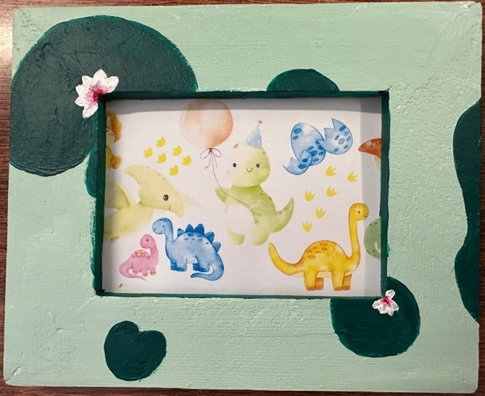
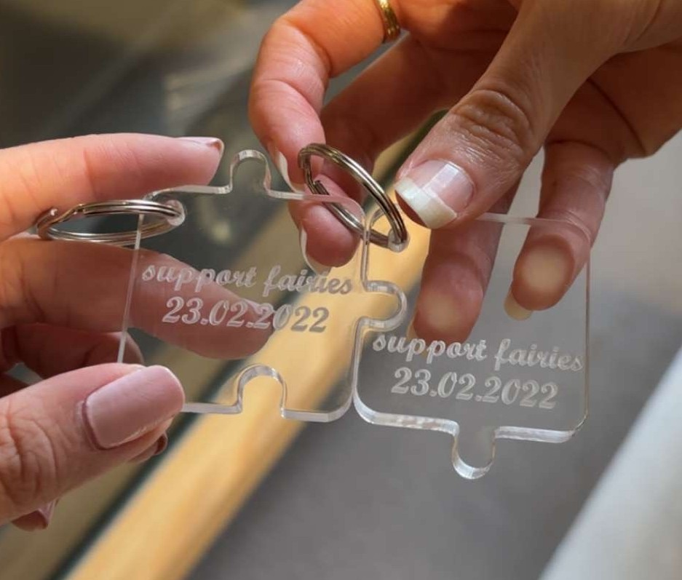

Case Study 2: Fostering Pre-Service Secondary Technology Teachers’ Agency
This case study focuses on a program that provides pre-service secondary teachers with early and sustained exposure to advanced workshop practices and digital technologies. Across several challenges, pre-service teachers engage with computer-aided design (CAD) and computer-aided manufacturing (CAM) platforms, laser cutters, routers, and 3D printers to prototype solutions to real-world design briefs (Kostakis et al., 2015; Kumpulainen et al., 2020).

Marble Sorting Challenge
The first challenge we describe aligns with the state’s Australian Tertiary Admission Ranking engineering (mechatronics) course and provides pre-service teachers with the foundational knowledge required to teach systems and control concepts at the senior secondary level. The challenge simulates an authentic industrial problem: the automated transportation and sorting of materials. To solve the challenge, pre-service teachers design and fabricate a device that transports marbles (13–16 mm in diameter), raising them to a height of 350–400 mm before sorting them according to predetermined parameters such as colour, size, or material type. Each of the three phases (loading, lifting, and sorting) requires a functioning subsystem controlled by a microcontroller, typically an Arduino (Resnick, 2024). To ensure the system operates reliably, pre-service teachers must integrate multimeter diagnostics, breadboarding, flowchart-based logic, and iterative testing.

In addition to constructing a fully functioning prototype, pre-service teachers produced a video in which they explained each component and evaluated its performance. Completing this challenge helped pre-service teachers develop confidence teaching complex systems and fostered their agency towards making with electronic and digital technologies. One pre-service teacher noted, “It was not easy, but once I conceptualised it, especially using SolidWorks, it made a lot more sense. I did have issues with the coding, but again I troubleshooted it until it worked.” By engaging with this design challenge, pre-service teachers also gained experience in instructional design and systems thinking, preparing them to deliver senior-level mechatronics content with authenticity and pedagogical depth (Ratto & Ree, 2012; Williams, 2023). See Figure 2 for examples of pre-service teachers’ work.

Figure 2
A Collection of Examples of How Pre-service Teachers Solved the Marble Sorting Challenge Using CAD Tools, Coding, and Digitally Fabricated Artefacts.
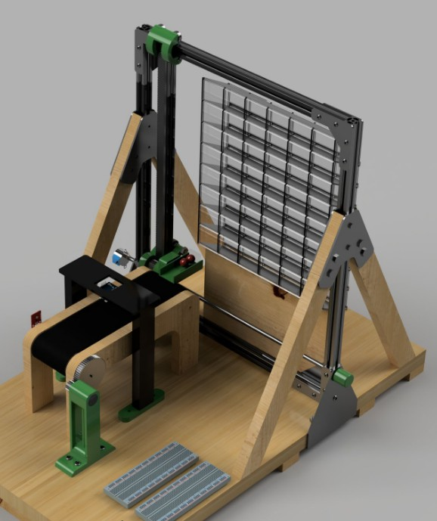
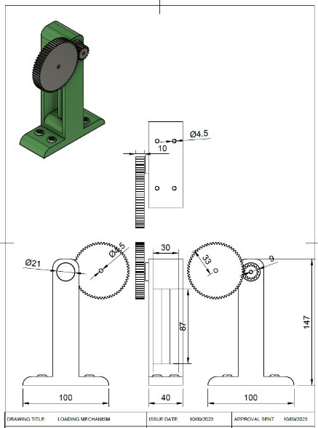
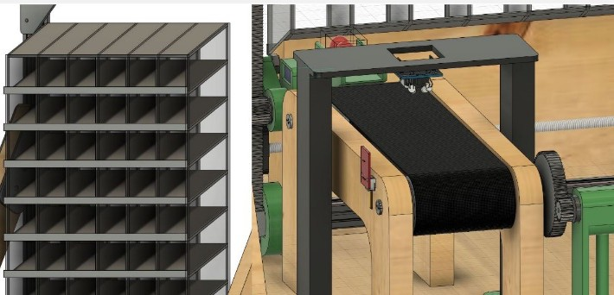
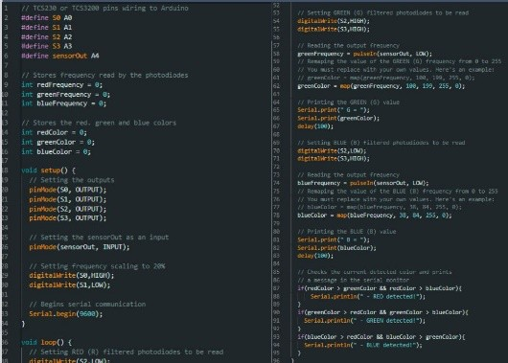

LasersRUs Product Challenge
The second challenge we describe engaged pre-service technology teachers in the various steps of the design process. During this challenge, we tasked pre-service teachers with designing a marketable product (e.g., lampshade, toy, or phone holder) for a hypothetical client, LasersRUs. We directed pre-service teachers to follow a brief that required investigation, ideation, 3D sketching, CAD production, and prototyping using a laser cutter (Zhang et al., 2017). The assessment included a comprehensive design portfolio that documented each stage of the process, from research and initial concepts through to final production and evaluation, mirroring authentic industry design processes (Allen et al., 2023; Ellis et al., 2025). The open-ended brief fostered much innovation and creativity (Giusti & Bombieri, 2020; Kolb, 2015; Puddicombe et al., 2025), resulting in a range of compelling and imaginative artefacts. We present one of these artefacts in the following section.

Fabricating Fantasy—Creating a Book Nook in the LasersRUs Challenge
Here we document Jane’s (pseudonym) creation of a book nook to satisfy the LasersRUs challenge. This example illustrates how Jane built agency towards making by engaging in design thinking and digital fabrication to create a miniature castle library suitable for placing on a bookshelf. The example is drawn from Jane’s written reflections and exemplifies how she engaged in iterative processes, solved technical challenges, and developed pedagogical insights.

From Inspiration to Ideation. Exposure to commercial book nooks on social media initially sparked Jane’s interest. A concurrent reading of dragon-centred fantasy fiction crystallised Jane’s thematic direction. Jane wanted to create an illuminated book nook framed by gothic architecture and watched over by distant, winged silhouettes. Jane recalled, “As an enthusiast of fantasy novels, it was only natural to connect the theme of the book nook to the literature I frequently enjoy.” With this connection, she centred the project on user experience, emphasising wonder, immersion, and a strong narrative appeal as its core design values. Early ideation sessions unfolded on a whiteboard, where sketches of castellated walls, ornate windows and arched bookshelves combined into a coherent design plan. This early rough sketching allowed Jane to quickly visualise her ideas and laid the foundation for more detailed digital modelling.
Digital Modelling and the Discipline of Precision. Transitioning from sketch to screen, Jane used the CAD program Fusion 360 to generate her book nook’s parametric geometry, leveraging its intuitive interface for large-scale box modelling. Jane subsequently refined furniture elements such as chairs, a circular table, and decorative corbels in the CAD program SolidWorks, whose mechanical design affordances supported accurate joinery and kerf allowances. Jane’s use of two types of CAD software reflected a pragmatic, tool-agnostic mindset as she commented, “SolidWorks provided greater precision and an intuitive interface whose features are better suited for detailing mechanical aspects in sketching and assemblies.” By iteratively toggling back and forth between programs, she was able to balance aesthetic ambition with manufacturability.
Prototyping, Laser Cutting, and the Realities of Materiality. Jane verified the scale and fit using cardboard maquettes before using 3 mm medium-density fibreboard (MDF), an economical and laser-friendly substrate, to create her book nook. She fabricated the components on a Trotec Speedy 400, chosen for its speed and repeatability. Jane quickly encountered the challenge of converting her digital design into a physical form. Fusion 360’s export routines failed to convert spline-based brick patterns into clean DXF paths, causing the software to crash. After several hours of trial and error, Jane sought help from a peer who suggested a workaround to capture the pattern in CorelDRAW, amplify the contrast, and route the file through Trotec Ruby software. She noted, “I could finally refine the design and produce a clean, high-contrast version that was perfect for engraving. This solution saved time and made the best visual outcome for the final piece after hours of work.”

Learning Trajectories and Emerging Pedagogical Identity. Throughout the challenge, Jane’s agency towards making grew, not only in navigating different software tools or achieving precise results with the laser cutter, but in thinking like a future technology teacher. She reflected on her ability to switch tools during tasks, effectively manage her time in a busy makerspace, and allow for exploration through trial and error (Ellis et al., 2025; Kolb, 2015; Tan et al., 2024). A turning point came when she realised the health and environmental risks associated with MDF’s formaldehyde-based adhesives. This prompted a shift in her thinking: “I started asking myself, would I feel comfortable asking students to use this?” From that moment, Jane began to rethink her role, not just as a maker, but as a teacher. Life cycle analysis and ethical material choices became part of how she planned and reflected. This shift marked significant growth in her journey, demonstrating how her values were starting to align with the responsibilities of a future technology teacher.

Reflections on Jane’s Iterative Design Process. Jane’s progression throughout the project demonstrated the value of iterative design in developing both technical skills and creative confidence. As illustrated in Figure 3, the initial concept, a relatively straightforward book nook, evolved significantly as she experimented with materials and fabrication techniques. The inclusion of wall-mounted picture frames emerged from exploratory scoring on the laser cutter, showing responsiveness to material feedback and a growing sense of aesthetic judgment. Jane later added windows to the left side of the book nook to enhance illumination and contribute to a more immersive, castle-like ambience, strengthening the thematic coherence of the piece. Rather than leaving the bookshelf empty, Jane fabricated miniature books from foam board, applying spines from well-known fantasy titles to personalise the scene and enhance narrative richness. One of the most distinctive additions was a floor rug crafted from fraying scrap fabric, aged using a blowtorch to convey a sense of texture and time.

Collectively, these modifications demonstrate how the iterative process facilitated Jane’s deep engagement with both material experimentation and narrative design, resulting in an artefact that reflected the thoughtful integration of form, function, and personal expression. Reflecting on the process, Jane stated, “This experience has strengthened my conviction that I can integrate creative design with practical fabrication skills and accomplish any task I set my mind to.”

Figure 3
Images Illustrating How Jane Progressed Through the Book Nook Challenge.
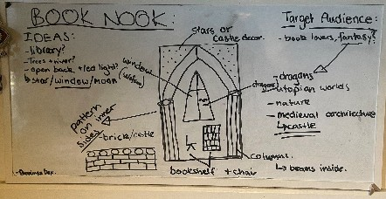
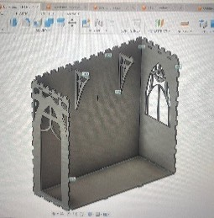
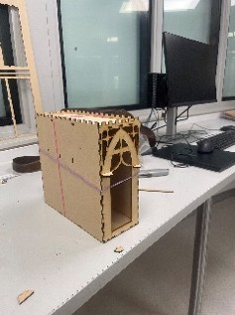
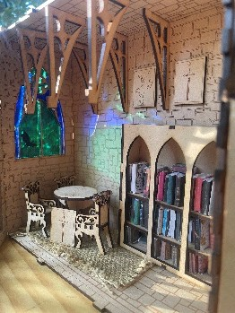
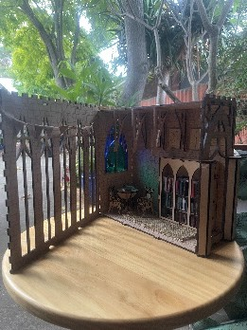

Case Study 3: Developing Pre-Service Teachers’ Agency Using a Values-Based Task
This case study focuses on a program that emphasises values-led design and local problem-solving. Specifically, pre-service teachers solved a values-based assessment that integrated digital systems and prototyping to address authentic community needs.

Sustainable Development Goals
Teachers play an important role in empowering their own students to analyse complex issues and find innovative and sustainable solutions to localised problems (Gupta & Sigdel, 2024; Dhaka, 2024). One entry point for teachers doing this important work are the United Nations’ sustainable development goals (SDGs) (United Nations, 2015). These 17 SDGs embody values such as equality, sustainability, and peace for all in a foreseeable future. An example of a similar value embedded in the Australian Curriculum that is meant to contribute to global citizenship is the cross-curriculum priority, sustainability (ACARA, 2022).

Because we believe in designing for sustainability, pre-service technology teachers were required to complete a task in which they incorporated aspects of global citizenship as an exercise in developing the capability to address concepts such as sustainability and human rights when teaching. Guided by the

perspective, “Think globally, yet act locally,” we aimed to develop pre-service teachers’ agency towards making by addressing different values embedded in the curriculum.

Launching the Task: Tackling a Real-World Values-Based Problem
We created a course called Digital Technologies: Principles and Processes. Completing this course supported pre-service teachers to build the foundational knowledge, skills, and understandings required to teach digital technologies content in Australian primary and secondary schools. The end-of-course task called for pre-service teachers to develop a solution to a local problem that could contribute towards the progress of meeting global SDGs. The task was underpinned by constructionist principles and encouraged active learning and engagement (Niiranen, 2021). The two-part task was as follows:
- Part 1: Design an inclusive garden in which a micro:bit smart sensor can be used to measure and respond to changes in soil moisture and/or temperature and/or light and/or motion. Be sure to provide suitable adjustments to cater for someone with additional needs, such as an elderly person or a student with a disability.
- Part 2: Link to one of the SDGs that identifies an authentic, real-world problem. For example, you could link to SDG 2: Zero Hunger.
Completing values-based tasks facilitates the development of knowledge and skills through contextualised and concrete experiences (Niiranen, 2021). This task required pre-service teachers to design and prototype both a 3D model and a digital solution for a garden that would contribute to the global efforts to address sustainability. In the past, we observed that pre-service teachers developed agency towards problem-solving, designing, and making by participating in this activity.

How did Pre-Service Teachers Engage with the Task?
By targeting large-scale issues (Scharon et al., 2024) such as the United Nations’ SDGs, pre-service teachers were forced to consider how the solutions they designed reflected a complex set of values related to sustainability. We found that this experience facilitated pre-service teachers wrestling with what it meant to “Think globally, yet act locally.” This phrase took on new meaning for the pre-service teachers as their solutions had to address SDGs but were also contextualised locally. Additionally, the task challenged pre-service teachers to develop creative solutions through the “entanglement of maker and matter” (Mehto & Kangas, 2023, p. 70). Doing this led pre-service teachers to increase their agency towards making as well as confidence engaging in practical skills such as coding and 3D modelling, and using design processes as a project management framework.
When faced with solving this complex real-world problem, pre-service teachers proposed actions informed through critical thinking (Prasad & O'Malley, 2022). For example, one pre-service teacher, Scott (pseudonym), targeted the concept of achieving sustainable food practices and improving overall health and well-being (linking explicitly to SDGs 3 and 11). In the process of empathising with the needs of an elderly client, Mavis, Scott learned that she required a garden to produce her own food, however—due to her advanced age—Mavis was at risk of falling in the garden. To ensure Mavis’s safety, Scott developed a solution to inform Mavis’s carers in the event she fell while in the garden (see Figure 4). This solution included programming the micro:bit to progress through several steps when its internal accelerometer detected a large change in pitch (indicating that Mavis fell).

Figure 4
Scott’s Solution to the Task. Should Mavis Fall in the Garden, the micro:bit Will Progress Through a Series of Actions, Eventually Sending an Alert via an App for Assistance.
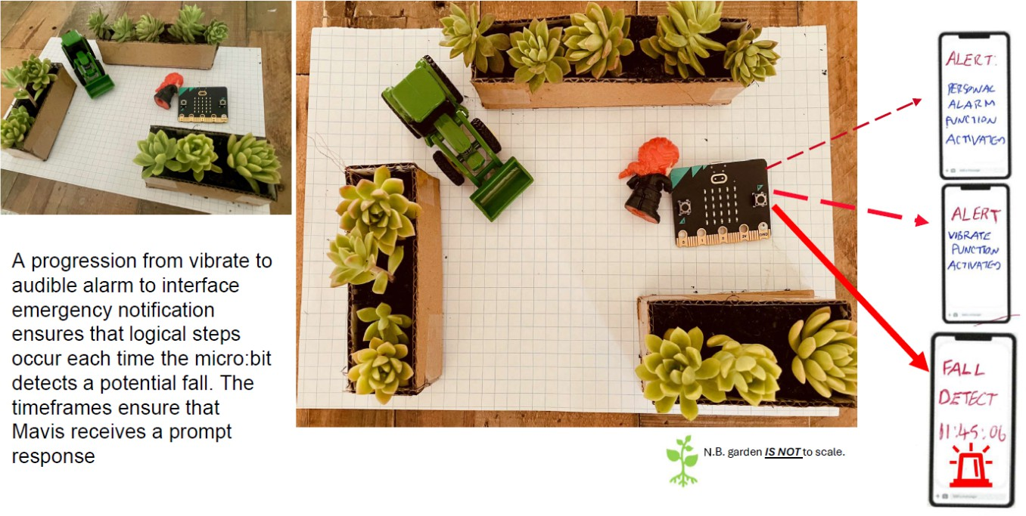

Discussion
In this paper, we reported case studies from three different technology ITE programs across Australia in which pre-service primary and secondary teachers developed agency towards making. In the first case study, we described how pre-service primary teachers participated in a variety of activities in a university makerspace. We found that structured access to the makerspace, proper orientation, staff support, and explicit tool training appeared to reduce barriers and promote pre-service teachers’ participation in makerspace activities. These observations align with evidence that makerspaces catalyse innovation, tool competence, and ownership (Barrett et al., 2015; Farritor, 2017; Saorín et al., 2017).

In the second case study, we explained how pre-service secondary teachers solved unique open-ended challenges by blending the design process with using digital fabrication tools. We found that these activities supported the development of systems thinking and adaptive expertise, as pre-service teachers integrated mechanical, electronic, and computational subsystems under real constraints (Anthony et al., 2015; Martin et al., 2015). In addition, we also found that these activities could shift pre-service teachers’ attention to material health and environmental risks, demonstrating a widening of professional judgement beyond technical knowledge towards responsible choices (Zhang et al., 2017).
In the third case study, we outlined how pre-service teachers engaged in solving a values-based task to prepare them for addressing values such as sustainability and global citizenship present in the curriculum. By requiring pre-service teachers to justify their design decisions against stakeholder needs, the task positioned them to exercise agency (Biesta et al., 2015; Emans et al., 2025). This coupling of ethics and artefact, evident in the “think globally, act locally” framing, reflects maker education’s characteristic entanglement of social values, materials, and digital systems (Dhaka, 2024; Gupta & Sigdel, 2024).

Limitations and Future Research
The case studies in this paper draw on the perspective of the lead academic responsible for the technology ITE program at three different Australian universities. Thus, they reflect individual interpretations shaped by institutional priorities, regional needs, and professional experience. While this design provides rich contextual insights, findings are not generalisable across technology ITE programs.

Future research could expand on this case study approach to include the other Australian universities that offer technology ITE programs, providing a more complete national picture of how the field is conceptualised and sustained. Given the limited number of institutions involved in technology education, a collaborative, multi-institutional study would offer valuable insights into technology ITE program curriculum design. Such research could strengthen our understanding of how universities collectively support the growth and continuity of the technology teaching profession in Australia.

Conclusion
Orchestrating innovative experiences for pre-service technology teachers is important because it supports them confidently and creatively making and—more broadly—supports them to be agents of change in their own classrooms once they become teachers. In addition, providing pre-service teachers with these types of experiences allows them to make concrete connections to knowledge, processes, and cross-curriculum priorities found in the Australian Curriculum (ACARA, 2022). In each of the case studies we presented, pre-service teachers engaged in different parts of the design process such as planning, evaluating, problem solving, and iterating products. At each step in the process, pre-service teachers were empowered to express themselves through making. Because of their experience taking on challenges and solving problems, these pre-service teachers are better prepared to support their own students making in the classes they teach in the future.

References
Allen, K. H., Balaska, A. K., Aronson, R. M., Rogers, C., & Short, E. S. (2023). Barriers and benefits: The path to accessible makerspaces. Proceedings of the 25th International ACM SIGACCESS Conference on Computers and Accessibility, 1–14. https://doi.org/10.1145/3597638.3608414
ACARA [Australian Curriculum, Assessment, and Reporting Authority]. (2022). Australian Curriculum: Version 9.0. https://www.australiancurriculum.edu.au/
Andrews, M. E., & Boklage, A. (2024). Alleviating barriers facing students on the boundaries of STEM makerspaces. Education Sciences, 14(7), 772. https://doi.org/10.3390/educsci14070772
Anthony, G., Hunter, J., & Hunter, R. (2015). Prospective teachers’ development of adaptive expertise. Teaching and Teacher Education, 49, 108–117. https://doi.org/10.1016/j.tate.2015.03.010
Australian Institute for Teaching and School Leadership [AITSL]. (2011). Australian Professional Standards for Teachers. Education Services Australia.
Barrett, T. W., Pizzico, M. C., Levy, B., Nagel, R. L., Linsey, J. S., Talley, K. G., Forest, C. R., & Newstetter, W. C. (2015). A review of University makerspaces. 2015 ASEE Annual Conference and Exposition Proceedings, 26.101.1-26.101.17. https://doi.org/10.18260/p.23442
Biesta, G., Priestley, M., & Robinson, S. (2015). The role of beliefs in teacher agency. Teachers and Teaching: Theory and Practice, 21(6), 624–640. https://doi.org/10.1080/13540602.2015.1044325
Darling-Hammond, L. (2021). Defining teaching quality around the world. European Journal of Teacher Education, 44(3), 295–308. https://doi.org/10.1080/02619768.2021.1919080
Davies, S., & Seitamaa-Hakkarainen, P. (2025). Research on K-12 maker education in the early 2020s – A systematic literature review. International Journal of Technology and Design Education, 35(2), 763–788. https://doi.org/10.1007/s10798-024-09921-6
Dhaka, R. (2024). Role of teachers and higher education in achieving the Sustainable Development Goals. International Journal for Multidisciplinary Research, 6(1), 1–9. https://doi.org/10.36948/ijfmr.2024.v06i01.11792
Ellis, D. (2024). Technology education teacher professional learning: Enabling the future [Southern Cross University]. https://doi.org/10.25918/thesis.519
Ellis, D., Rouse, R., Rowston, K., Puddicombe, C., von Mengersen, B., & Levins, M. (2025). Students as makers using technologies. In M. Bower & B. von Mengersen (Eds.), Creative technologies education: Students as digital designers (pp. 172–189). Routledge. https://doi.org/10.4324/9781003435281

Emans, A., Oolbekkink-Marchand, H., Bakker, C., & De Bruijn, E. (2025). Teacher agency in the dynamics of educational practices: a theory synthesis. Frontiers in Education, 9. https://doi.org/10.3389/feduc.2024.1515123
Farritor, S. (2017). University-based makerspaces: A source of innovation. Technology and Innovation, 19(1), 389–395. https://doi.org/10.21300/19.1.2017.389
Gupta, A. K., & Sigdel, T. S. (2024). Integrating Sustainable Development Goals in local plans: Unlocking practices and challenges of local governments in Nepal. Heliyon, 10(20), 14. https://doi.org/10.1016/j.heliyon.2024.e39615
Giusti, T., & Bombieri, L. (2020). Learning inclusion through makerspace: A curriculum approach in Italy to share powerful ideas in a meaningful context. Campus-Wide Information Systems, 37(3), 73–86. https://doi.org/10.1108/IJILT-10-2019-0095
Halliburton, P., Georgiou, H., & Nielsen, W. (2024). Makerspaces: Building confidence in STEM for primary preservice teachers. Research in Science Education, 54(4), 573–594. https://doi.org/10.1007/s11165-024-10153-w
Hammerness, K., Darling-Hammond, L., Bransford, J., Berliner, D., Cochran-Smith, M., McDonald, M., & Zeichner, K. (2005). How teachers learn and develop. In L. Darling-Hammond, & J. Bransford (Eds.), Preparing teachers for a changing world. (pp. 358–389). Jossey-Bass.
Heredia, S. C., & Fisher, M. (2022). Makers-in-Residence: An apprenticeship model for supporting pre-service elementary teachers to adopt making tools and technologies. TechTrends, 66(5), 760–770. https://doi.org/10.1007/s11528-022-00751-8
Koehler, M. J., Mishra, P., & Cain, W. (2013). What is technological pedagogical content knowledge (TPACK)? Journal of Education, 193(3), 13–19. https://doi.org/10.1177/002205741319300303
Kolb, D. A. (2015). Experiential learning: Experience as the source of learning and development (2nd ed.). Pearson Education Inc.
Kostakis, V., Niaros, V., & Giotitsas, C. (2015). Open source 3D printing as a means of learning: An educational experiment in two high schools in Greece. Telematics and Informatics, 32(1), 118–
128. https://doi.org/10.1016/j.tele.2014.05.001
Kumpulainen, K., Kajamaa, A., Leskinen, J., Byman, J., & Renlund, J. (2020). Mapping digital competence: Students’ maker literacies in a school’s makerspace. Frontiers in Education, 5. https://doi.org/10.3389/feduc.2020.00069
Martin, T., Ko, P., Baker Peacock, S., & Rudolph, J. J. (2015). Changes in teachers’ adaptive expertise in an engineering professional development course. Journal of Pre-College Engineering Education Research (J-PEER), 5(2), 35. https://doi.org/10.7771/2157-9288.1050
Mehto, V., & Kangas, K. (2023). Materiality in invention pedagogy. In T. Korhonen, K. Kangas, & L. Salo (Eds.), Invention Pedagogy – The Finnish Approach to Maker Education (pp. 70–79).
Routledge. https://doi.org/10.4324/9781003287360-7
Melo, M. M., & Rodney, R. (2023). Space invaders: First-time users feel like intruders in the makerspace. Library & Information Science Research, 46(4), 101264. https://doi.org/10.1016/j.lisr.2023.101264
Millar, R. (2004). The role of practical work in the teaching and learning of science. Commissioned paper for the Committee on High School Science Laboratories: Role and Vision (pp. 1–21).
National Academy of Sciences.
Niiranen, S. (2021). Supporting the development of students’ technological understanding in craft and technology education via the learning-by-doing approach. International Journal of Technology and Design Education, 31(1), 81–93. https://doi.org/10.1007/s10798-019-09546-0
OECD. (2011). Teachers matter: Attracting, developing and retaining effective teachers. Directorate for Education, Education and Training Policy Division. http://www.oecd.org/education/school/48627229.pdf
Pettersen, I. B., Kubberød, E., Vangsal, F., & Zeiner, A. (2020). From making gadgets to making talents: Exploring a university makerspace. Education & Training, 62(2),145–158. https://doi.org/10.1108/ET-04-2019-0090
Prasad, S., & O’Malley, C. B. (2022). An introductory framework of problem-based learning (PBL) and perspectives on enhancing facilitation approaches. HAPS Educator, 26(3), 52.
Puddicombe, C., Rouse, R., Tolomei, M., & Ellis, D. (2025). Students as designers with 3D design and fabrication technologies. In M. Bower & B. von Mengersen (Eds.), Creative technologies

education: Students as digital designers (pp. 157–171). Routledge. https://doi.org/10.4324/9781003435281
Puddicombe, C. K., & Williams, P. J. (2020). Technology teacher education in Australia. In L.-S. Lee (Ed.), International technology teacher education in the Asia-Pacific region (pp. 1–45). Central Taiwan University of Science and Technology and Ministry of Education.
Quintana-Ordorika, A., Garay-Ruiz, U., & Portillo-Berasaluce, J. (2024). A systematic review of the literature on maker education and teacher training. Education Sciences, 14(12), 1310. https://doi.org/10.3390/educsci14121310
Ratto, M., & Ree, R., (2012). Materializing information. First Monday. 17(7). https://doi.org/10.5210/fm.v17i7.3968
Resnick, M. (2024). Generative AI and creative learning: Concerns, opportunities, and choices. An MIT exploration of Generative AI. https://doi.org/10.21428/e4baedd9.cf3e35e5
Rouse, R., & Gillespie Rouse, A. (2022). Taking the maker movement to school: A systematic review of preK-12 school-based makerspace research. Educational Research Review, 35, 100413. https://doi.org/10.1016/j.edurev.2021.100413
Saorín, J. L., Melian-Díaz, D., Bonnet, A., Carbonell Carrera, C., Meier, C., & De La Torre-Cantero,
J. (2017). Makerspace teaching-learning environment to enhance creative competence in engineering students. Thinking Skills and Creativity, 23, 188–198. https://doi.org/10.1016/j.tsc.2017.01.004
Scharon, C. J., Phillips, A., & Jones-Davis, D. (2024). The mind of a maker: a learning framework for a continuum of K-12 invention education. Frontiers in Education, 9,10. https://doi.org/10.3389/feduc.2024.1352274
Stake, R. E. (1995). The art of case study research. SAGE.
Tan, J., Kinshuk, & Wu, L. (2024). The effectiveness of design thinking on K-12 school students’ creativity in a maker curriculum. Educational Technology Research and Development, 72(2), 1091–1110. https://doi.org/10.1007/s11423-023-10332-y
Tomko, M. E., Nagel, R. L., Newstetter, W., Smith, S. F., Talley, K. G., & Linsey, J. (2021). Making a makerspace: Identified practices in the formation of a university makerspace. Engineering Studies, 13(1), 8–29. https://doi.org/10.1080/19378629.2021.1916941
United Nations. (2015). Transforming our world: The 2030 agenda for sustainable development. resolution adopted by the General Assembly on 25 September 2015, 42809. https://docs.un.org/en/A/RES/70/1
Williams, P. J. (2023). Maker pedagogy. In R. M. Klapwijk, J. Gu, Q. Yang, & M. J. de Vries (Eds.), Maker education meets technology education (pp. 131-148). Brill. https://doi.org/10.1163/9789004681910_010
Yin, R. K. (2018). Case study research and applications: Design and methods (6th ed.). SAGE.
Zhang, Q., Wong, J. P. S., Davis, A. Y., Black, M. S., & Weber, R. J. (2017). Characterization of particle emissions from consumer fused deposition modeling 3D printers. Aerosol Science and Technology, 51(11), 1275–1286. https://doi.org/10.1080/02786826.2017.1342029

