
Editor: Associate Professor Wendy Fox-Turnbull, University of Waikato, New Zealand

Editorial board:

Prof Stephanie Atkinson, Sunderland University, England, United Kingdom Prof Marc de Vries, Delft University of Technology, Netherlands
Prof Mishack Gumbo, University of South Africa, South Africa Prof Jonas Hallström, Linkoping University, Sweden
Assoc Prof Kurt Seemann, Swinburne University of Technology Australia, Australia Prof David Spendlove, University of Manchester, England, United Kingdom
Prof Scott Warner, Millersville University, United States
Assoc Prof P John Williams, Curtin University, Western Australia, Australia
The Australasian Journal of Technology Education is a peer refereed journal and provides a forum for scholarly discussion on topics relating to technology education. Submissions are welcomed relating to the primary, secondary and higher education sectors, initial teacher education and continuous professional development, and general research about technology education. Contributions to the ongoing research debate are encouraged from any country. The expectation is that the Journal will publish articles at the leading edge of development of the subject area.
The Journal seeks to publish
- reports of research,
- articles based on action research by practitioners,
- literature reviews, and
- book reviews.
Publisher: The Technology, Environmental, Mathematics and Science (TEMS) Education Research Centre, which is part of the Division of Education, The University of Waikato, publishes the journal.
Contact details: The Editor, AJTE, wendy.fox-turnbull@waikato.ac.nz
Cover Design: Roger Joyce
This journal provides immediate open access to its content on the principle that making research freely available to the public supports a greater global exchange of knowledge.

ISSN: 2382-2007

From Users to Designers: A Sequenced Pedagogical Model for Human-centred Mechatronics Education in Schools
Katie Waters Natalie McMaster University of Newcastle Sunshine Coast Australia Australia

Abstract
The integration of robotics and control systems into education offers opportunities to develop students as designers and innovators, equipping them with essential skills across mechanics, electronics, computing and artificial intelligence for the future workplace. As mechatronics becomes increasingly embedded in education, the challenge is no longer introducing technology but guiding students to design human-centred solutions.
This paper proposes a research-informed pedagogical model for mechatronics education in schools that integrates Inquiry-Based Learning (IBL), Human-centred Design (HCD) and Project-Based Learning (PjBL) into a sequenced progression. Rather than treating these as isolated strategies, this paper demonstrates how their sequential alignment empowers students to create human-centred solutions, deepen engagement, ethical awareness, and interdisciplinary thinking. This model supports students in transitioning from being technology users to becoming thoughtful designers who consider human needs, values and social contexts in creating mechatronic systems. It advances current practice by providing a scalable framework that cultivates creativity, design, systems and computational thinking, ethical problem-solving and socially relevant innovation. Practical examples illustrate application across schooling contexts, from introductory robotics to advanced design challenges like autonomous vehicles. This paper contributes to technology education by presenting a practical, research-informed model that supports the development of future-ready school students.

Keywords
Human-centred design, project-based learning, mechatronics, systems thinking, inquiry-based learning

Introduction
As automation, robotics, and artificial intelligence increasingly shape society, education must evolve to prepare students not only to use technology but to design and critically engage with it (Waters et al., 2025). Mechatronics, which integrates mechanics, electronics, computing, and control systems, offers a powerful avenue for this transformation. However, meaningful engagement in mechatronics requires more than theoretical instruction. It calls for pedagogical approaches that nurture creativity and ethical awareness, while developing students’ skills in problem-solving, systems thinking, design thinking and computational thinking.
This paper introduces a sequenced pedagogical model that integrates three complementary active learning frameworks: Inquiry-Based Learning (IBL), Human-centred Design (HCD), and Project-Based Learning (PjBL). This integrated model scaffolds learning across cognitive, ethical and technical domains, supporting students’ transition from being passive users to becoming active designers of technology.
The unique contribution of this approach lies in its deliberate sequencing of pedagogies that are often implemented independently. IBL fosters curiosity and conceptual understanding (Hmelo-Silver et al., 2007); HCD transforms this understanding into empathetic, socially responsive design; and PjBL provides the organisational structure to realise and test these designs through extended, real-world projects (Zhang et al., 2024). Together, these frameworks form a coherent pedagogical model that keeps human needs, values and ethical considerations central to mechatronics learning. This paper contributes new insights to educational research by articulating how the structured sequence of these combined pedagogies supports transformative learning. The resulting model equips students not only with technical fluency but also with the empathy, creativity and critical insight needed to become thoughtful designers in a rapidly evolving technological landscape.

Literature

The role of mechatronics in education
Mechatronics offers a compelling educational pathway by integrating mechanics, electronics, and programming into cohesive, hands-on learning experiences. Rather than treating these fields as isolated disciplines, mechatronics encourages students to explore how different technologies interact within and across complex systems, fostering systems thinking and real-world problem-solving (Waters et al., 2025).
This interdisciplinary approach aligns with the International Society for Technology in Education (ISTE) Standards (2024), supporting progressive learning that builds from foundational concepts to sophisticated applications. For younger students in the early stages of school (K-2, children aged 5-7 years), learning may begin with unplugged activities (without the use of technology) or simple robotics using block-based coding, progressing to projects in secondary schooling designing motorised vehicles or sensor-based systems (Martin et al., 2024; MindSET-do, 2024). These projects not only develop algorithmic and computational thinking but also emphasise creativity and iterative design.
Engagement in robotics and control systems nurtures key skills like design thinking, debugging, and collaboration. Projects such as autonomous robots or sensor-triggered mechanisms give learners a practical framework for understanding automation and control logic (Greca Dufranc et al., 2020; Tengler et al., 2021).

These activities are particularly effective when contextualised using meaningful, real-world challenges, which encourage ethical problem-solving and attention to user needs, reinforcing student agency and relevance for their learning.
Furthermore, a mechatronics-based curriculum encourages playful experimentation and resilience through the development of systems thinking. Students learn to prototype, test, and refine their designs, mirroring authentic engineering processes and fostering innovation through trial and error (Albion et al., 2022; Zhang et al., 2024). Mechatronics education can be effectively integrated into science, technologies, engineering, and mathematics (STEM) because it inherently combines these disciplines and reflects how they operate together in real-world contexts. By embedding mechatronics within broader educational programs, schools can better prepare students for future careers in technology-rich environments, cultivating both technical proficiency and a mindset for continuous learning and improvement.

Inquiry-Based Learning (IBL)
IBL is a constructivist pedagogy grounded in the belief that students build knowledge through active engagement, questioning, and problem-solving. Influenced by educational theorists such as John Dewey (1938), Jean Piaget (1952), Lev Vygotsky (1978), and Jerome Bruner (1960), IBL promotes experiential, discovery-driven, and socially mediated learning. It empowers students to ask meaningful questions, investigate problems, test solutions, and refine ideas (Hmelo-Silver et al., 2007). This approach underpins contemporary models such as the International Baccalaureate and the Primary Years Programme, which adopt transdisciplinary frameworks that foster student agency, and deep understanding through authentic contexts (International Baccalaureate Organization, n.d.).
IBL centres on curiosity, questioning, and critical thinking, which are fundamental to supporting students to become designers and innovators, particularly in mechatronics (Darmawansah et al., 2023; Hmelo-Silver et al., 2007). Students are not passive recipients of knowledge but active participants in generating, testing, and applying ideas. Structured, guided and open inquiry fall under the umbrella of IBL, each offering varying levels of teacher direction and student autonomy. By retaining IBL as the umbrella concept, educators are empowered to select and adapt the level of guidance that best suits their learners, context, and curriculum goals, without narrowing the framework to a single mode of delivery.
In mechatronics education, IBL supports integrated STEM education to design and test intelligent systems. Murdoch (2015) has been instrumental in translating IBL into classroom practice, positioning it as both a mindset and a methodology that cultivates curiosity, creativity, and deeper thinking. The 5E Model: Engage, Explore, Explain, Elaborate, Evaluate (Bybee et al., 2006), offers a flexible scaffold for inquiry reflecting natural learning processes. Martin et al. (2024) recently introduced the 3C model (Construct, Contextualise, Communicate), for learning coding and computational thinking whereby students build digital artefacts through hands-on exploratory learning, relate them to real-world contexts and express their understanding through multimodal forms.
Rather than following instructions, students ask questions, identify problems, and test solutions with teacher guidance. For example, they might explore how a robot navigates an obstacle course or program a scanning device using touch sensors to help people who are blind recognise products (Martin et al., 2024). This interdisciplinary approach fosters computational thinking and metacognition. Research shows that IBL increases engagement and supports deep learning in STEM (Hmelo-Silver et al., 2007).

Table 1:
Key Distinctions of Inquiry-Based Learning (IBL)

Aspect Inquiry-Based Learning (IBL)

User role Active learner and investigator

Design focus Exploration, questioning and problem framing
Engagement scope Emphasises open-ended inquiry across the full design process

Human-centred Design (HCD)
HCD is a design philosophy that prioritises human needs, values, and social contexts (Norman, 2013, IDEO, 2015), whereby users are viewed as active co-creators rather than passive participants (Harvey & Ankiewicz, 2022). This approach cultivates ethical reasoning and civic responsibility, guiding learners to design technologies that promote functional, inclusive, and culturally responsive outputs.

Table 2:
Key Distinctions Between User-Centred Design (UCD) and Human-Centred Design (HCD)

Aspect User-Centred Design (UCD) Human-Centred Design (HCD)

User role Observed participant Active co-creator

Design focus Useability and task efficiency Empathy, ethics and social relevance

Engagement scope Involves users mainly during the
testing phase
Engages users throughout the design process

In manufacturing and engineering, HCD helps integrate human useability with technical system design (Nguyen Ngoc et al., 2022). When developing artificial intelligence (AI) systems, HCD principles are used to guide the development of ethical AI by involving human stakeholders throughout the design and evaluation (Topali et al., 2024). HCD is also used when designing digital resources for health education to ensure that they are accessible, contextually relevant and responsive to the needs of the user (Rosenbaum et al., 2025).
In mechatronics education, HCD engages students with the ethical and human dimensions of technology. Examples include programming a robot to assist a person with limited mobility or designing a self-driving car that prioritises pedestrian safety. HCD fosters critical thinking and moral reasoning guiding students to co-create ethical solutions that respond to authentic human needs and societal challenges (Harvey & Ankiewicz, 2022, IDEO, 2015).
Through inquiry, ideation, and prototyping, students learn to value multiple perspectives and question “who gets to design and for whom?” Research shows immersive HCD activities build both technical expertise and human-centred thinking (Ramírez-Cedillo et al., 2025).

Project-Based Learning (PjBL)
PjBL emphasises active, student-centred inquiry through authentic, real-world problems (Nghiem et al., 2025). It enables students to construct knowledge by building on prior understanding while collaboratively developing concrete artefacts (Elliott et al., 2000; Suradika et al., 2023). This approach is the use of meaningful, real-world problems as the context for learning, allowing students to engage in tasks that replicate the practices of professionals in STEM fields (Chang & Chen, 2023). Learning in PjBL is social and collaborative, involving teamwork amongst peers, teachers and sometimes external partners, promoting the establishment of a community of learners (Tsybulsky & Sinai, 2022). PjBL emphasises the creation of concrete artefacts or solutions as outcomes of the learning process (Suradika et al., 2023) and has been found to be effective in mechatronics education by fostering both technical competencies and developing teamwork skills (Kobras et al., 2024).
Although the primary focus of this section is PjBL, it is essential to include mention of Problem-based learning (PBL) due to their conceptual overlap and frequent pedagogical blending in classroom practice (Ralph, 2016). PBL is an instructional method that engages students in exploring and resolving open-ended problems, with a primary focus on developing conceptual understanding and analytical thinking (Suradika et al., 2023). While both PBL and PjBL involve problem-solving, their aspects differ, see Table 3. PBL primarily focuses on understanding and applying abstract concepts, whereas PjBL places greater emphasis on designing and producing a concrete product as the culmination of learning (Suradika et al., 2023). The assessment strategies for each of these approaches remain distinct.

Table 3:
Key Distinctions Between Problem-Based Learning (PBL) and Project-Based Learning (PjBL)

Aspect Problem-Based Learning (PBL) Project-Based Learning (PjBL)

User role Problem-solver responding to a predefined issue
Creator engaged in developing a tangible solution or product

Design focus Understanding and resolving a real-world problem
Designing and producing a concrete product outcome

Engagement scope Structured around investigating a
central problem
Spans across sustained tasks involving multiple phases in the design process

PjBL replicates authentic engineering practice, encouraging interdisciplinary collaboration and systems thinking as students design robotic or automated solutions. Research confirms that this enhances engagement, real-world skills and learning outcomes (Llopis-Albert et al., 2025; Zhang & Ma, 2023).

Sequencing of IBL, HCD and PjBL
IBL, HCD, and PjBL are often presented as distinct pedagogical strategies; however, their underlying principles are highly complementary. While research explores intersections between IBL and PjBL (Nghiem et al., 2025) or between PjBL and PBL (Ralph, 2016; Suradika et al., 2023), little scholarship explicitly models their sequential alignment in mechatronics or technology education. Existing studies often treat these approaches as parallel rather than progressive. Consequently, opportunities to intentionally scaffold learning from inquiry to empathy and then to application remain underexplored. This alignment has potential to integrate creativity, collaboration, systems thinking, and ethical awareness, ensuring the human element remains central in mechatronic design.

Pedagogical model for human-centred mechatronics education
Building on these foundations, this paper turns to pedagogical practice, examining how structured, research-informed frameworks can move mechatronics education beyond technical skill development towards creative human-centred innovation. Specifically, it demonstrates how IBL, HCD, and PjBL can be organised into an interdisciplinary progression that nurtures design thinking, systems thinking, computational thinking, and ethical problem-solving (see Figure 1).

Figure 1:
Pedagogical Model for Human-Centred Mechatronics Education
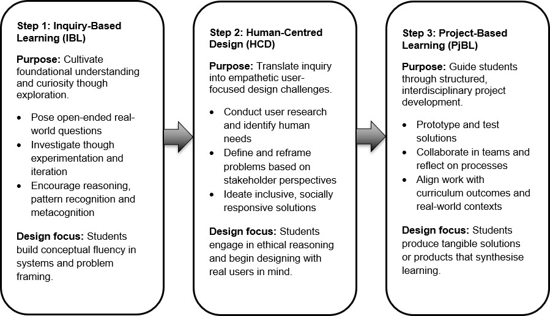

Step 1: Inquiry-based learning
Mechatronics naturally fosters inquiry and systems thinking. As students explore how mechanical, electronic, and computational components interact, they develop awareness of interconnections and feedback loops, seeing themselves as designers and systems thinkers. IBL empowers them to investigate, experiment, and iterate, focusing on how systems work and why design decisions matter. "How can I make my Bee-Bot reach a target without bumping into anything?"
From this, children generate their own questions:
- How do I instruct the robot to go forwards, backwards or turn? (see Figure 2)
- What happens if I press the wrong button?
- Can I guide it around an obstacle? (see Figure 3)

Figure 2: Figure 3:
A Basic Bee-Bot Coding Sequence Navigating the Bee-Bot Around an Obstacle
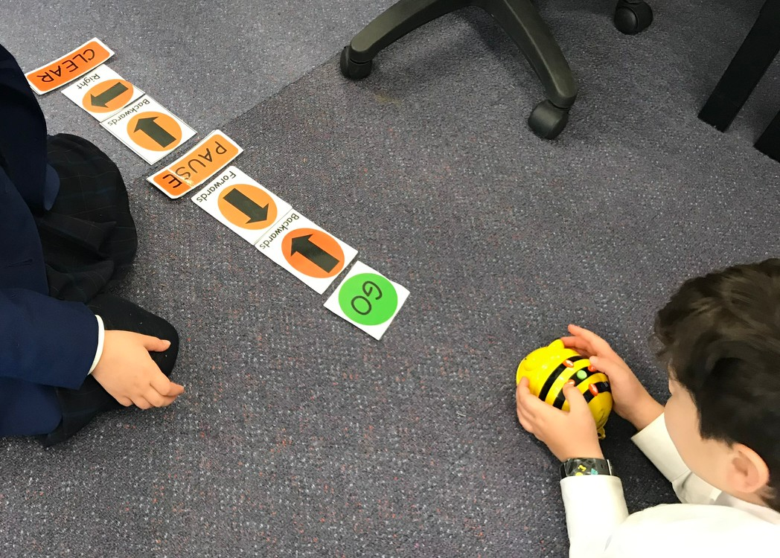
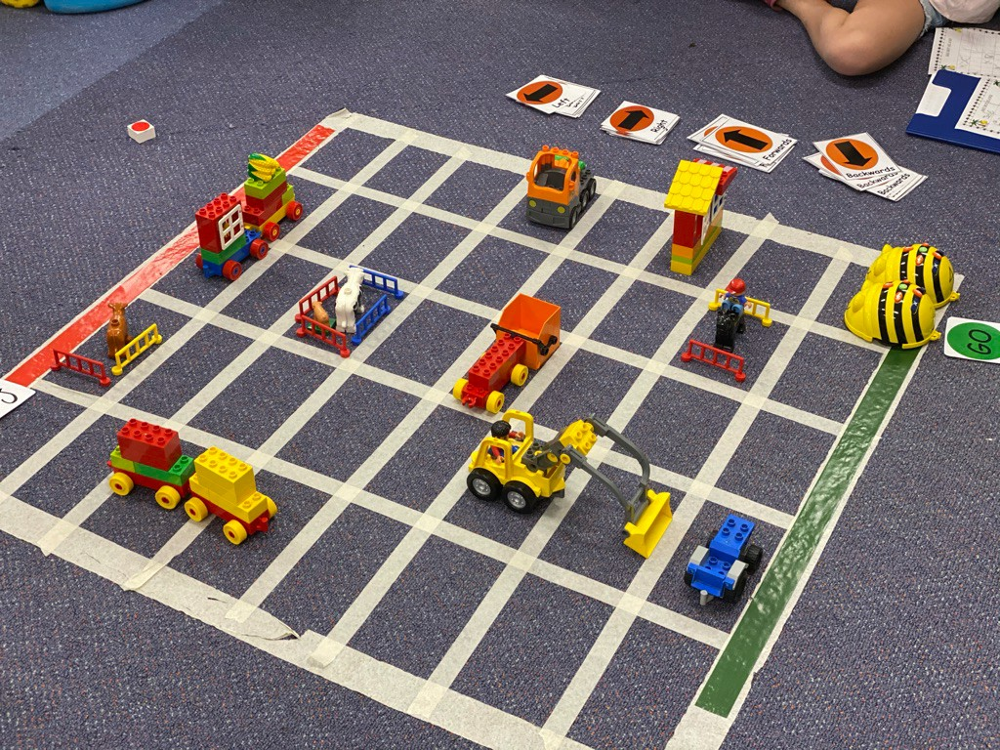
Young learners test, observe and revise their commands, developing early computational thinking. They begin to understand the relationship between instructions and actions, a precursor to coding. Educators scaffold this learning by encouraging children to record their paths, estimate steps and reflect on what went right or wrong, making mathematical and logical thinking visible through play.
In the primary years, IBL develops as students explore deeper concepts using robots like the Pro-Bot. These allow students to drop a pen into the centre, providing instant visual feedback as they program movement, direction and rotation. These concepts align with numeracy and offer engaging ways to explore mathematics.
A typical inquiry question might be:

“What programming will instruct the Pro-Bot to move accurately to create geometric shapes?”
Students explore how to answer the following questions:
- How can I drive my robot in a straight line?
- How do I make a 90-degree turn?
- Can I draw a square or triangle?

Figure 4: Figure 5:
Students Collaborate to Code a Square Exploring Interior and Exterior Angles
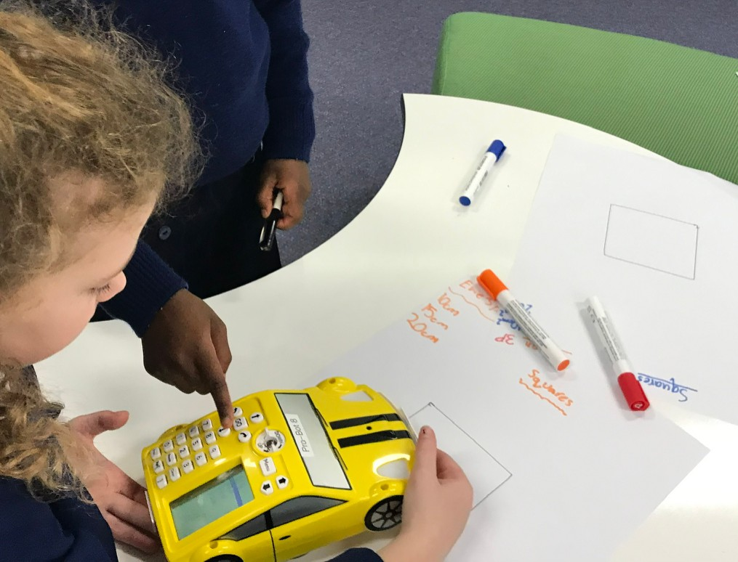
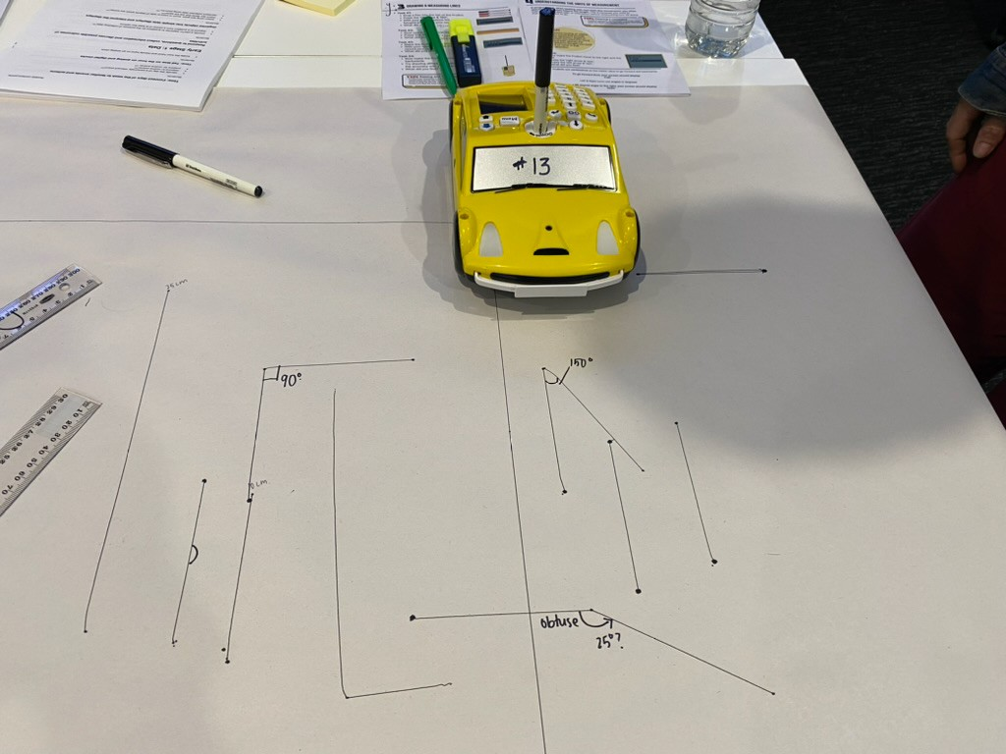
Tasks like these promote spatial reasoning, angle knowledge, measurement and geometry. As shown in Figures 4 and 5, students may program the robot to move 30 cm, then turn 90 degrees and repeat the sequence to create a square. Initially, students input each step manually. Over time, they identify patterns

and repetition, leading to the use of loops and procedures, introducing computational thinking and mathematical generalisation.
Students also discover key geometric ideas, such as the robot drawing the external edge of a shape rather than the internal angles, prompting deeper reasoning about angle properties. As their understanding grows, students experiment with creative challenges:
- Can I make a repeating pattern by rotating after each shape?
- Does the same logic work for triangles or pentagons?
This learning progression highlights curriculum coherence and the value of knowledge transfer. Students draw on core mathematical concepts:
- Measurement: estimating and calculating distances
- Angles: understanding turns and rotations
- Spatial reasoning: planning routes and direction
- Data: recording outcomes and identifying patterns
These skills are embedded in meaningful, open-ended tasks that promote reasoning and iteration. In upper primary, inquiry becomes more sophisticated. A central question might be:

“What does it take to design a self-driving car that can move safely, respond to its environment and make ethical decisions?”
This question invites rich, interdisciplinary exploration across mathematics, science, digital technologies and ethics. Students begin to consider empathy and human-centred design as part of engineering thinking. Their inquiries extend to understanding input, process and output systems:
- Inputs: sensors detect light, obstacles or lines
- Processing: logic and conditionals (if/then) guide the car’s behaviour
- Outputs: movement, lights, sounds or displays such as LEDs or buzzers
Students reverse engineer and iterate to understand how a car can stop, turn, navigate and park using code and real-time sensor data.
From manual control to automated decision-making, this builds on earlier learning:
- Driving a robot in a straight line using measured distances
- Turning using angle knowledge
- Navigating a maze with sequenced instructions
- Stopping for objects, reverse parking or navigating tight spaces New inquiry questions emerge:
- How can we make a robot stop when it senses a person or wall?
- How far ahead must it detect an obstacle to stop in time?
- Can it slow down approaching a corner?
- Could it reverse park using only sensors and programmed angles?
- How can we ensure it behaves safely and respectfully around people?
These questions encourage student-led investigations using measurement, estimation, trial and error and geometric reasoning. Students begin thinking not just about how their robot functions, but how it responds to people, introducing empathy and ethics.
Integrating sensors, logic and mathematics, students explore how various sensors, such as ultrasonic, infrared and line trackers, detect environmental changes. This input data is processed through logic programs (e.g., using MakeCode or Scratch) to determine how the car responds (see Figure 6).

Figure 6:
Programming Obstacle Avoidance with MakeCode using micro:bit with Maqueen
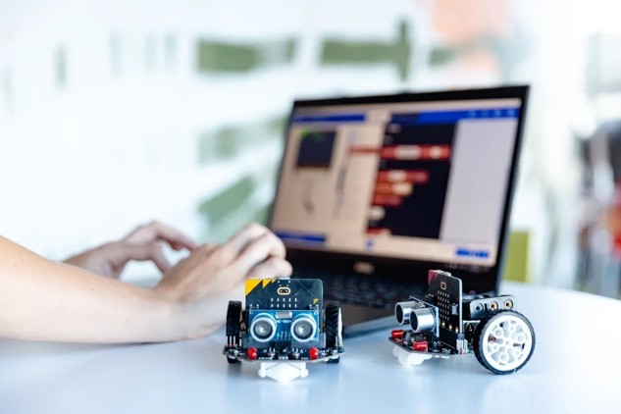
Key mathematical concepts include:
- Estimation and measurement: deciding how far to travel before stopping or turning
- Angles: calculating precise turn angles for corners or parking
- Spatial reasoning: positioning and proximity to obstacles
- Data analysis: recording test results and evaluating success rates
Students work with platforms such as micro:bit with Maqueen, LEGO Spike / Prime or Tinkerbots. They use coding tools like MakeCode or Scratch to implement:
- Forward movement and line-following
- Obstacle detection and stopping
- Angle-based parking procedures
- Ethical rules such as stopping for people or yielding A parking challenge might involve:
- Measuring the minimum space required
- Programming a turning sequence using angles
- Calibrating sensors to detect walls and vehicles
- Refining the design based on test data
As students shift to systems thinking, they begin exploring broader, speculative questions:
- Can a car make decisions entirely on its own?
- How could multiple self-driving cars communicate to avoid crashes?
- If connected to a network, could they respond to each other’s movements in real time?
- What would a fully automated city traffic system look like?
These questions invite simulation and modelling. Students might design simplified networks where multiple robots follow shared traffic rules or signal each other (e.g., via micro:bit radio or light sensors) to test coordinated responses and accident prevention.
IBL embeds mathematics in authentic, real-world contexts. Students see measurement, geometry and data not as abstract skills but as tools for engineering solutions. They are also introduced to broader questions of empathy and social responsibility. This integrated learning prepares students for more advanced computational and systems thinking, building the capacity for creative problem-solving in future-focused STEM fields.

Step 2: Human Centred Design
HCD deepens inquiry by placing human needs at the core. Students ask who benefits from a design and how inclusivity, ethics, and usability are addressed. Activities such as mapping user journeys, interviewing peers, or designing accessible interfaces connect empathy with engineering reasoning.
Building on the initial inquiry question in Step 1, “How can we design a self-driving car that can sense, decide and move accurately on its own?” it is essential that students place human needs at the centre of their design process. Designing for people means going beyond functionality, to consider the user’s needs, feelings, physical and cognitive abilities, and the contexts in which they will use the car.
Students are encouraged to ask critical human-centred questions such as:
- Who will be riding in the car? (children, adults, grandparents, people with disability)
- What features would ensure safety and comfort? (obstacle detection, braking systems)
- How can I make the features more accessible and inclusive? (voice controls, seat design)
Classroom learning activities can support this process through authentic, hands-on engagement. Some educator prompts and classroom ideas include:
- Give students a transport-related product (e.g., an electric scooter, bicycle helmet, seat belt) and ask them to identify who the products were designed for, what features help users and what might exclude someone from using them?
- Engage students in “a day in the life of” narrative which asks them to think about the perspective of a user of a self-driving car, e.g., an elderly person, considering their mobility, comfort, safety, independence and how the car responds to them
- Interviewing peers and a range of community members to understand real-world transport challenges and user needs
- Setting up design constraints which mean that students need to design for a specific user need, e.g., designing a voice interface for someone who does not speak English or designing controls which work without hands
- Mapping the user journey from start to end when using a self-driving car, identifying the key touchpoints (e.g., getting in, setting a destination, stopping, parking), highlighting main points, and proposing improvements
- Integrate user-centred design tasks that address accessibility, trust, safety, cultural context, and ethics across the entire transport journey.
- Engage students in discussions in response to ethical scenarios, e.g., should the car prioritise passengers or pedestrians in an accident? How is user privacy and data protected?
Students sketch or use programs like Fritzing to create concept drawings of the vehicle layout, and they create systems diagrams to show how sensors (ultrasonic, IR or infrared), motors and code work together (see Figure 7). For example, a student might design an accessibility button panel for people with limited mobility and/or low vision. Their design could have large, high-contrast touchpads that send signals to control the car's doors or navigation system. Their diagram could show how pressing a button triggers a microcontroller to activate a servo motor that opens the door slowly, while simultaneously playing an audio cue for users with low vision.

Figure 7:
A Systems Diagram for an Ultrasonic Sensor and Warning Lights Using an Arduino
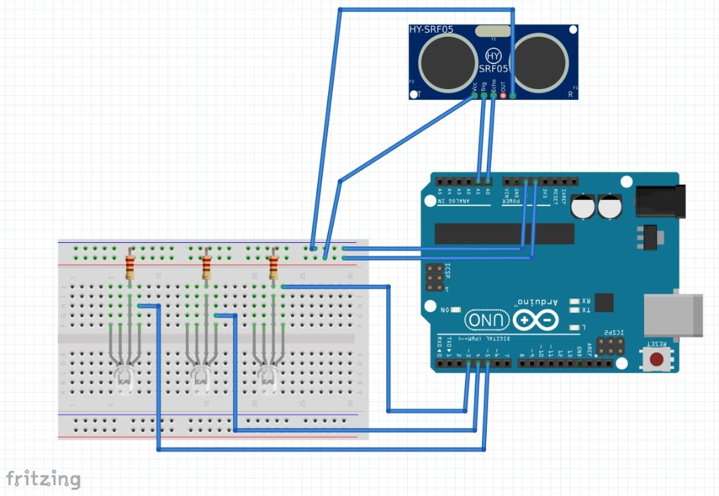
Investigating how a self-driving car can be more accessible or user-friendly provides rich opportunities for interdisciplinary STEM learning through Technologies and Mathematics as outlined in Step 1. In Science, concepts such as motion, force and materials can be explored to understand how the car operates and interacts with its environment. Engineering principles such as systems design, control systems, sensor integration and safety engineering are embedded in the learning.
This inquiry cultivates ethical understanding, critical and creative thinking and collaborative problem-solving, empowering students to create solutions that are inclusive, empathetic and socially responsive. When designing the self-driving car, every feature should reflect a thoughtful response to human needs, ensuring the final design is not only technically effective but also inclusive, empathetic and user centred.

Step 3: Project-Based Learning
While IBL cultivates curiosity and system-level understanding, and HCD promotes ethical, human-centred thinking, these phases do not necessarily lead to a tangible outcome. PjBL extends this process by guiding students to apply their knowledge through the design, testing, and refinement of concrete solutions. In this collaborative phase, students manage timelines, develop prototypes, and evaluate outcomes, transforming inquiry and design into authentic, hands-on learning (Nghiem et al., 2025). PjBL emphasises implementation and accountability, requiring students to produce a product that addresses real-world needs. It is underpinned by six core principles (Blumenfeld et al., 1991; Krajcik et al., 1994; Krajcik & Czerniak, 2013) outlined below in the context of mechatronics education and the three steps of the proposed model.

- Learning begins with a central driving question – this initial question occurs in Step 1 (IBL) and is further explored and refined in Step 2 (HCD).
- Learning activities are based on learning outcomes and aligned with learning standards – while the students explore and create, the educator carefully scaffolds each stage of the learning by unpacking the learning outcomes and aligning them with disciplinary content.
- Students investigate the central question through engagement in a range of learning areas – drawing from prior learning in science, technology, engineering, mathematics and humanities, students apply their knowledge through the lens of creativity, design thinking, systems thinking, computational thinking, ethical problem-solving and socially relevant innovation.
- Collaborative problem-solving involves students, educators, and members of the wider community – informed by the Step 2 (HCD) emphasis on co-design and stakeholder engagement,

students incorporate real human perspectives and iterate designs based on feedback, working closely with peers, teachers and potential users.
- Students are scaffolded with learning technologies that help them solve the problem – educators guide students in the Step 1 (IBL) and Step 2 (HCD) phases by introducing tools such as sensors, simulators, and coding platforms to support inquiry, then scaffolding the purposeful use of age-appropriate technologies like microcontrollers, robotics and design software.
- Students produce concrete outputs that directly address the driving question – the final product may be a working prototype or a detailed design solution, but the product must demonstrate not just technical proficiency but also human-centred thinking and ethical consideration.
Building on this design-focused work in Step 1 (IBL) and Step 2 (HCD), students transition into PjBL by taking the initial concepts and moving towards prototyping and production. In this Step, students collaborate in teams to allocate roles, manage project timelines and gather materials (see Figure 8). Using microcontrollers (e.g., Makey Makey, micro:bit, Arduino) and robotics platforms (e.g., Bee Bot, LEGO Spike, Sphero, Pro-Bot), students begin developing a functional prototype, coding the sensors and motor responses they previously diagrammed. As they implement their design, they engage in continuous evaluation and testing. They collect feedback from peers and simulated users and refine their prototype accordingly. Throughout the project, the students document their process and reflect on how well their final product meets the needs of the user and address the central driving question (see Figure 9).

Figure 8: Figure 9:
An Example Production Plan Worksheet An Example Evaluation Worksheet

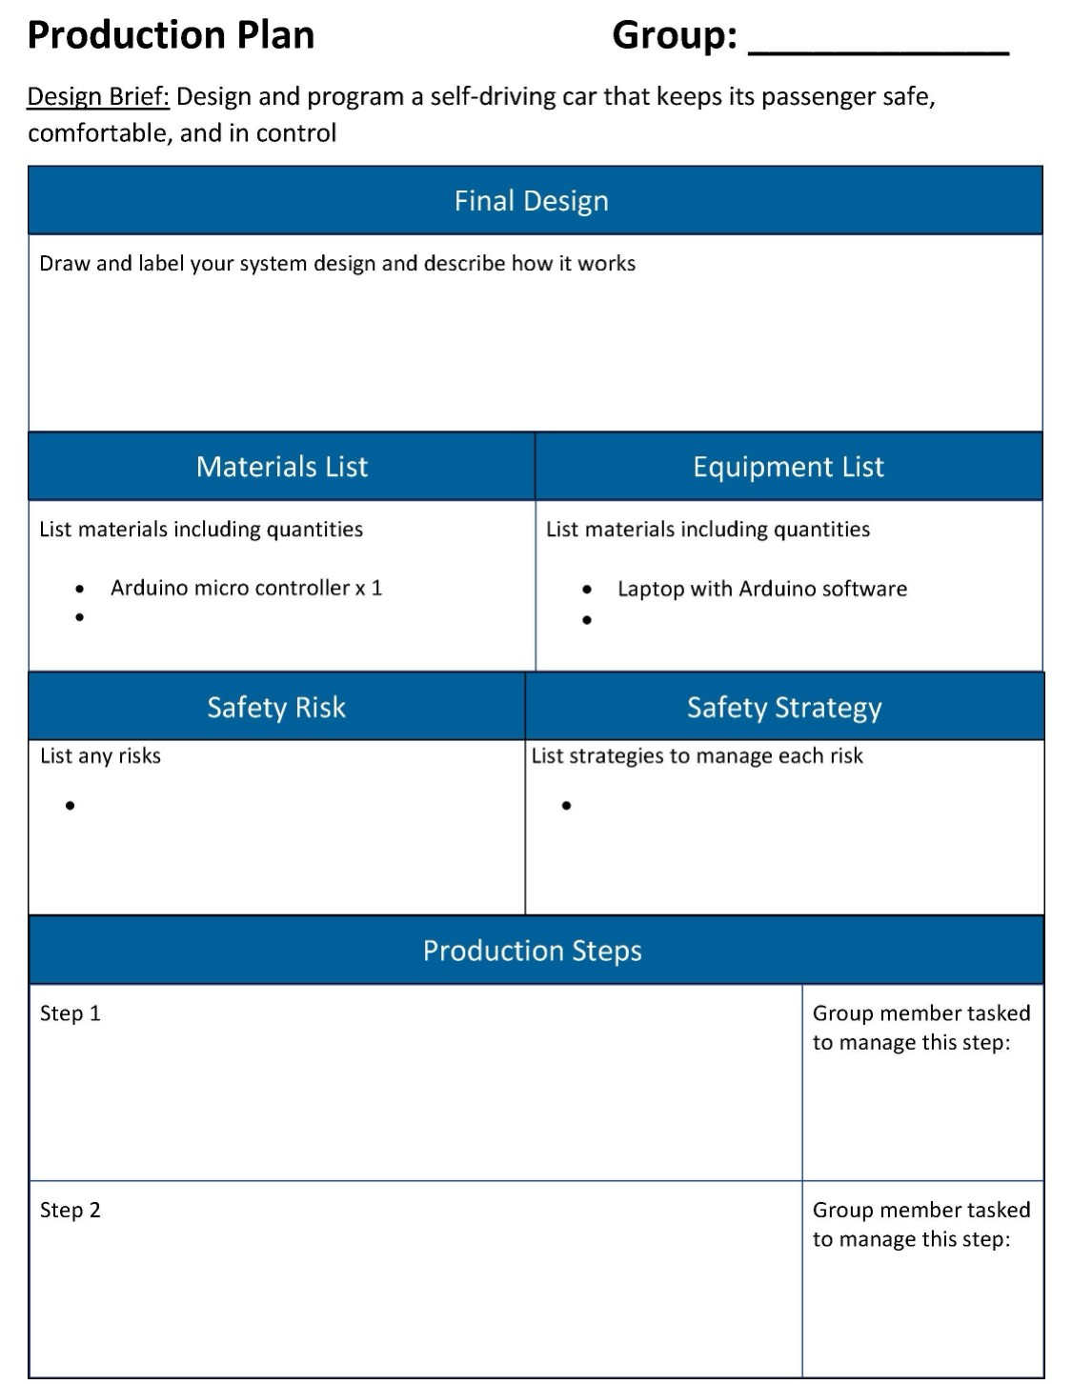

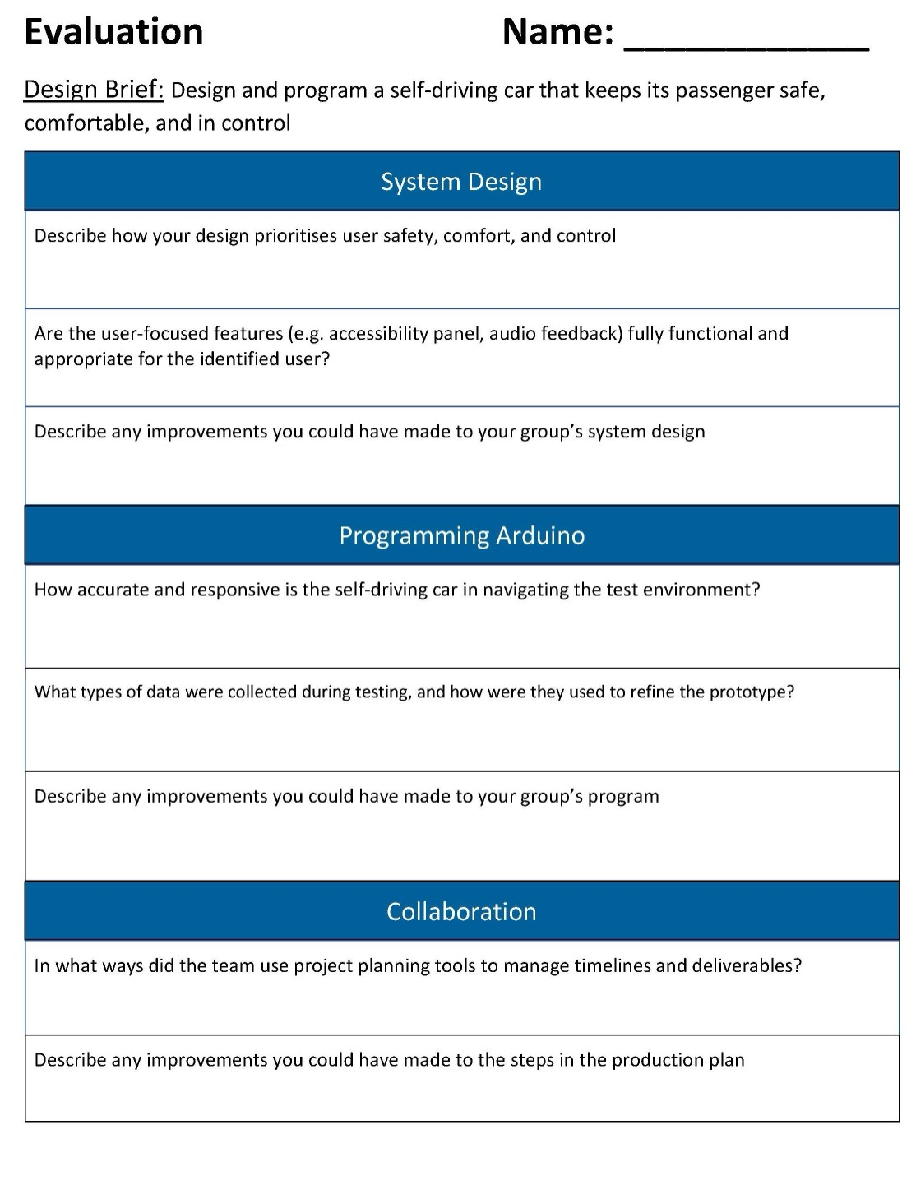

Using the pedagogical model for human-centred mechatronics education
The following examples illustrate how the sequenced progression of IBL, HCD, and PjBL operates across different stages of schooling through an autonomous vehicle project. Building on the theoretical foundation outlined earlier, these examples show how students’ progress from exploration and questioning to empathy-driven design, and finally to hands-on creation and evaluation. Each stage develops core STEM skills while embedding ethical reasoning and social responsibility. PjBL adds the dimension of action, guiding students to transform understanding of user needs into tested, refined solutions. Together, IBL, HCD, and PjBL

create a coherent pedagogical model that scaffolds learning from inquiry to empathy to implementation, enabling students to design meaningful, human-centred solutions through collaborative, real-world projects.

Early childhood example
Driving question: “How can we help a robot car keep people in our community safe while it moves?”

Step 1: IBL - Exploring robot cars. Students:
- Describe Bee-Bot movements (speed, direction, stop/pause)
- Test and record different movements
- Explain what a Bee-Bot can/cannot do

Step 2: HCD – Understanding people’s needs
- Identify how different people (elderly, pet owners) feel around self-driving cars
- Draw or describe features to help cars keep people safe

Step 3: PjBL – Designing and testing
- Create a map of the local area with roads, parks, people
- Program the Bee-Bot to navigate safely (pause at crossings, stop at traffic lights)
- Observe if the Bee-Bot keeps people safe
- Present project and explain safety features

Upper primary example
Driving question: “How can we program a self-driving car to detect and avoid obstacles like people, pets and other cars?”

Step 1: IBL – Investigating autonomous systems. Students:
- Explore self-driving car concepts using micro:bit, Maqueen bots or LEGO Spike
- Investigate sensors (infrared, ultrasonic)
- Experiment with programming and test behaviours (stop, avoid obstacles, follow path)

Step 2: HCD – Designing for people and safety
- Develop personas and real-life scenarios
- Discuss car responses to people, pets, vehicles
- Brainstorm features (slowing near parks, lights/sounds)
- Create annotated sketches or mock-ups

Step 3: PjBL – Building and testing navigation
- Build and program a self-driving car with obstacle-detecting sensors
- Program safety responses (stop, slow, reroute)
- Integrate HCD features (alerts, interface)
- Test in dynamic environments, collect data and feedback
- Refine and present how the car protects community members

Secondary schooling example
Driving question: "How can we design and program a self-driving car that keeps its passenger safe, comfortable, and in control?"

Step 1: IBL – Exploring intelligent systems and human-autonomy interaction. Students:
- Investigate autonomous vehicles, sensors, and decision-making
- Explore passenger experience and communication of automated decisions
- Generate sub-questions on safety, control, comfort
- Experiment with microcontrollers (micro:bit, Arduino, Raspberry Pi) and components (LEDs, buzzers, LCDs, buttons)

Step 2: HCD – Designing for human needs
- Identify users and explore needs via journey maps, interviews
- Define design problems based on user experience
- Brainstorm and sketch solutions (tactile buttons, voice navigation, simplified dashboards)
- Ensure inclusivity, ethics, and real-world relevance

Step 3: PjBL – Prototyping and testing
- Form teams with assigned roles
- Plan tasks and timelines
- Build prototypes with microcontrollers, motors, sensors
- Integrate HCD features (alerts, accessibility)
- Test in simulated environments, collect performance data
- Refine design and reflect on safety, comfort, and control

Conclusion
Selecting a pedagogical framework is not a one-size-fits-all decision. It should be guided by real-world problems students explore, the cognitive and creative skills we aim to develop, and the need to integrate curriculum outcomes across learning areas. This paper advocates for a sequential progression of IBL, HCD and PjBL to develop both the technical and human capacities essential for meaningful mechatronics learning.
While these approaches overlap one another, each emphasises different facets of the learning process. IBL fosters curiosity, conceptual exploration, and critical problem-solving through questioning, hypothesis testing, and deep engagement (Albion et al., 2022). HCD builds on this by centring empathy, ethical reasoning, and creative ideation, ensuring that design solutions address functional needs and the human experience (IDEO, 2015). PjBL extends these insights into real-world application, promoting systems thinking, interdisciplinary knowledge transfer, and collaborative innovation through authentic projects (Zhang et al., 2024).
This sequenced progression cultivates design, computational, and systems thinking alongside ethical decision-making. By aligning each phase with curricular goals and authentic engineering challenges, educators can guide students to become competent problem-solvers and ethically aware designers who code with purpose, think in systems, design with empathy and reflect critically to navigate the complex, interdisciplinary landscape of mechatronics and STEM education (Waters et al., 2025).

References
Albion, P., Campbell, C., & Jobling, W. (2022). Technologies education for the primary years (2nd ed.).
Cengage Learning.
Blumenfeld, P. C., Soloway, E., Marx, R. W., Krajcik, J. S., Guzdial, M., & Palincsar, A. (1991).
Motivating project-based learning: Sustaining the doing, supporting the learning. Educational Psychologist, 26(3), 369–398. https://doi.org/10.1207/s15326985ep2603&4_8

Bruner, J. S. (1960). The process of education. Harvard University Press.
Bybee, R. W., Taylor, J. A., Gardner, A., Van Scotter, P., Powell, J. C., Westbrook, A., & Landes, N. (2006). The BSCS 5E Instructional Model: Origins and ‘effectiveness’. BSCS. https://bscs.org/reports/the-bscs-5e-instructional-model-origins-and-effectiveness
Chang, C. C., & Chen, Y. K. (2023). A transdisciplinary STEM course integrated through Project-based learning on robotics: Perspective from teacher and student feedback. Asia Pacific Journal of Education, 45(2), 661–676. https://doi.org/10.1080/02188791.2023.2209698
Darmawansah, D., Hwang, G. J., Chen, M. R. A., & Liang, J. C. (2023). Trends and research foci of robotics-based STEM education: A systematic review from diverse angles based on the technology-based learning model. International Journal of STEM Education, 10(1), 12. https://doi.org/10.1186/s40594-023-00400-3
Dewey, J. (1938). Experience and education. Macmillan.
Elliott, S.N., Kratochwill, T.R., Littlefield Cook, J., & Travers, J. (2000). Educational psychology: Effective teaching, effective learning (3rd ed.). McGraw-Hill.
Greca Dufranc, I. M., García Terceño, E., Fridberg, M., Cronquist, B., & Redfors, A. (2020). Robotics and early-years STEM education: The botSTEM framework and activities. European Journal of STEM Education, 5(1), 1–13. https://doi.org/10.20897/ejsteme/7948
Harvey, N., & Ankiewicz, P. (2022). Human-centered design pedagogies to teach values in technology education. In: P. J. Williams, & B. von Mengersen (Eds.), Applications of research in Technology education. Contemporary Issues in Technology Education. Springer. https://doi.org/10.1007/978-981-16-7885-1_8
Hmelo-Silver, C. E., Duncan, R. G., & Chinn, C. A. (2007). Scaffolding and achievement in problem-based and inquiry learning: A response to Kirschner, Sweller, and Clark (2006). Educational Psychologist, 42(2), 99–107. https://doi.org/10.1080/00461520701263368
IDEO. (2015). The field guide to human-centered design: Design kit. https://www.ideo.com/journal/design-kit-the-human-centered-design-toolkit
International Baccalaureate Organization. (n.d.). International education. https://www.ibo.org/ International Society for Technology in Education [ISTE). (2024). ISTE Standards.
https://iste.org/standards
Kobras, L., Haase, J., & Soll, M. (2024). Advantages and challenges using project-based learning for building automation classes. 2024 IEEE 3rd German Education Conference (GECon), Munich, Germany, 2024 (pp. 1-6). https://doi.org/10.1109/GECon62014.2024.10734027
Krajcik, J. S., Blumenfeld, P. C., Marx, R. W., & Soloway, E. (1994). A collaborative model for helping middle grade teachers learn project-based instruction. The Elementary Schools Journal, 94(5), 483–
497. https://doi.org/10.1086/461779
Krajcik, J. S., & Czerniak, C. M. (2013). Teaching science in elementary and middle school classrooms: A project-based approach, (4th ed.). Taylor and Francis.
Llopis-Albert, C., Rubio, F., Mata-Amela, V., Devece, C., Palacios-Marqués, D., & Zeng, S. (2025).
Enhancing transversal competences through project-based learning: Integrating sustainable development goals in mechatronics engineering. Multidisciplinary Journal for Education, Social and Technological Sciences, 12(1), 95–124. https://doi.org/10.4995/muse.2025.23139
Martin, D. A., Curtis, P., & Redmond, P. (2024). Primary school students’ perceptions and developed artefacts and language from learning coding and computational thinking using the 3C model. Journal of Computer Assisted Learning, 40(4), 1616–1631. https://doi.org/10.1111/jcal.12972
MindSET-do. (2024, August 1). Self-driving car using micro:bit. https://mindset-do.edu.au/schools/secondary/year-7/
Murdoch, K. (2015). The power of inquiry: Teaching and learning with curiosity, creativity and purpose in the contemporary classroom. Seastar Education.
Nghiem, X. H., Yadav, R., Yadav, M., Dewasiri, N. J., & Ranasinghe, A. (2025). Project-based learning and inquiry-based learning. In M. A. Wilkins (Ed.), Exploration of K-12 teaching and learning for

teacher educators (pp. 231-260). IGI Global Scientific Publishing. https://doi.org/10.4018/979-8-3693-9370-3.ch009
Nguyen Ngoc, H., Lasa, G. & Iriarte, I. (2022). Human-centred design in industry 4.0: Case study review and opportunities for future research. Journal of Intelligent Manufacturing, 33, 35–76. https://doi.org/10.1007/s10845-021-01796-x
Norman, D. A. (2013). The design of everyday things: Revised and expanded edition. Basic Books. Piaget, J. (1952). The origins of intelligence in children. International Universities Press.
Ralph, R. A. (2016). Post secondary project-based learning in science, technology, engineering, and mathematics. Journal of Technology and Science Education, 6(1), 26-35. https://www.redalyc.org/pdf/3311/331144428004.pdf
Ramírez-Cedillo, E., Armendáriz-Rodríguez, M., García-Ávila, J., Quintero-Sánchez, D., Ortiz-Espinoza, A.A., & Vargas-Martínez, A. (2025). Student 5.0: Immersive learning in next-gen automation of manufacturing systems courses for the industry 5.0 era. Frontiers in Education. https://doi.org/10.3389/feduc.2025.1416761
Rosenbaum, S., Moberg, J., Chesire, F., Mugisha, M., Ssenyonga, R., Ochieng, M. A., Simbi, C. M. C., Nakyejwe, E., Ngatia, B., Rada, G., Vásquez-Laval, J., Garrido, J. D., Baguma, G., Kuloba, S., Sebukyu, E., Kabanda, R., Mwenyango, I., Muzaale, T., Nandi, P., … Oxman, M. (2025). Teaching critical thinking about health information and choices in secondary schools: Human-centred design of digital resources. F1000Research 2024, 12:481. https://doi.org/10.12688/f1000research.132580.3
Suradika, A., Dewi, H. I., & Nasution, M. I. (2023). Project-based learning and problem-based learning models in critical and creative students. Journal Pendidikan IPA Indonesia, 12(1), 153-167. https://doi.org/10.15294/jpii.v12i1.39713
Tengler, K., Kastner-Hauler, O., Sabitzer, B., & Lavicza, Z. (2021). The effect of robotics-based storytelling activities on primary school students’ computational thinking. Education Sciences, 12(1), 10. https://doi.org/10.3390/educsci12010010
Topali, P., Ortega-Arranz, A., Rodríguez-Triana, M. J., Er, E., Khalil, M., & Akçapınar, G. (2024).
Designing human-centered learning analytics and artificial intelligence in education solutions: A systematic literature review. Behaviour & Information Technology, 44(5), 1071–1098. https://doi.org/10.1080/0144929X.2024.2345295
Tsybulsky, D., & Sinai, E. (2022). IoT in project-based biology learning: Students’ experiences and skill development. Journal of Science Education and Technology, 31, 542–553. https://doi.org/10.1007/s10956-022-09972-1
Vygotsky, L. S. (1978). Mind in society: The development of higher psychological processes. Harvard University Press.
Waters, K., Martin, D. A., McMaster, N., Zunica, B., Tregenza, B., & Levins, M. (2025). Students as designers with robotics and control systems. In Creative Technologies Education (pp. 138-156). Routledge. https://doi.org/10.4324/9781003490715-10
Zhang, L. & Ma, Y. (2023). A study of the impact of project-based learning on student learning effects: A meta-analysis study. Frontiers in Psychology, 14, 1202728. https://doi.org/10.3389/fpsyg.2023.1202728
Zhang, W., Guan, Y. & Hu, Z. (2024). The efficacy of project-based learning in enhancing computational thinking among students: A meta-analysis of 31 experiments and quasi-experiments. Education and Information Technologies. https://doi.org/10.1007/s10639-023-12392-2

